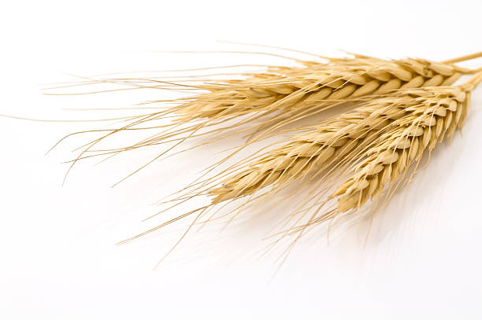

# *Secale cereale* Species Distribution Modelling

Methods in Biodiversity analysis report

1. **Introduction**

Rye, *Secale cereale* subsp. *cereale,*  is a grain crop which originates from central and eastern Turkey. It is suitable as a crop in Europe because of its winter hardiness, resistance to drought and its ability to grow on acid, sandy soils ( Zohary, Hopf & Weiss, 2012). The optimal pH for growth is between 5.6 and 6.5 (University of Wyoming: Department of Plant Sciences, n.d.). Rye is a cross-pollinated cereal and therefore yield depends on effective wind pollination. This is different from most grain crops that are self-pollinating ( Zohary, Hopf & Weiss, 2012).

In the wild rye is centred in west and east Asia. After the end of the last European Ice Age, rye was cultivated and brought from Turkey to Western Asia and Europe. Currently the grain crop is spread out over all almost all continents, but is mostly centred in Europe (Figure 1).

The objective of this report is to investigate the effect of relevant climate conditions for the present and future species distribution of rye.

|  |  |
| --- | --- |
|  |  |
|  |  |

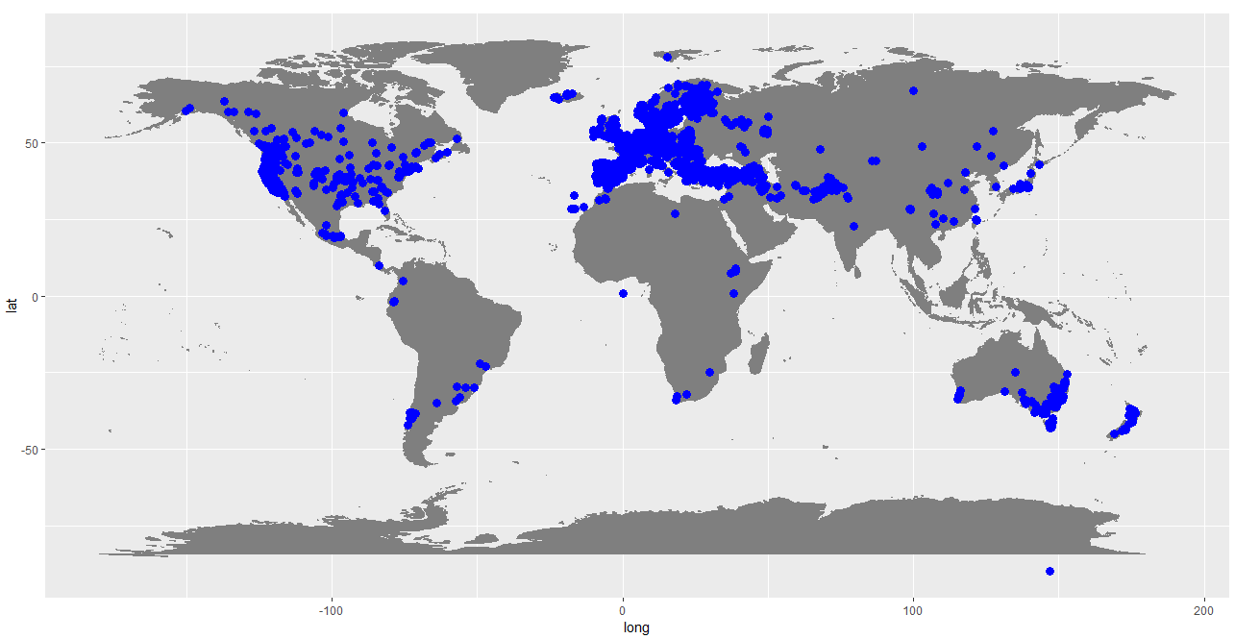

Figure 1: Worldwide occurrence data of *Secale cereale* (GBIF, 2017)

1. **Methods**

To gather the occurrence data for *Secale cereal L.*, a database from GBIF was used. In total there were 42,506 occurrences described and used in the analysis. To look at the effect of climate on the current and future distribution of rye, a set of bioclimatic variables were used from WorldClim version 1.4. For future predictions the RCP4.5 scenario at 5m (HadGEM2-CC) was chosen for the year 2050. In this stabilization scenario total radiative forcing is stabilized after the year 2100 (Thomson et al., 2011).

Suitable independent variables were chosen by looking at correlations between the bioclimatic variables with a threshold of 0.7 with Spearman’s correlation. Bio6, bio16 and bio17 were chosen which are respectively Min Temperature of Coldest Month, Precipitation of Wettest Quarter and Precipitation of Driest Quarter. Because of the winter hardiness of this crop, minimal temperature of the coldest month was seen as an important bioclimatic variable. Because rye is quite resistant to drought, it is also important to look at variables indicating moisture. To look at the longer term fluctuations in precipitation patterns, we chose to look at the wettest and driest quarter.

A species distribution model was created in the program Maxent, version 3.4.1. The output format was set to logistic and no Jackknife resampling technique was used.

1. **Results**
   1. Model performance

The AUC value of the model was 0.812. The AUC value predicts the accuracy of the model, where 0.5 means the model is performing just as good as a random prediction, and AUC = 1 means 100% accuracy. The AUC value of 0.812 would therefore seem like a sufficient model performance.

According to the model, the minimum temperature of the coldest month was the most important variable in predicting the species distribution.

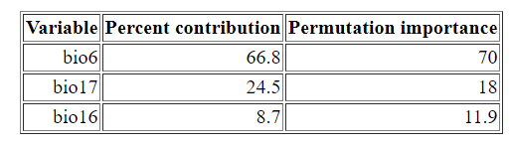

Table 1: Variable importance table

* 1. Current suitable habitat

The model showed suitable habitat for rye with a threshold of 0.498 (maximum training sensitivity), illustrated in figure 2. This closely follows the current GBIF occurrences of *Secale cereale,* except for parts of Africa and Russia where the crop is most likely cultivated and grows with the aid of humans in an area where it naturally would not grow.

There are also areas where rye does not grow, while the model predicts a suitable climate for the growth of the crop. Possibly rye is simply not introduced in these areas for different reasons: geographical barriers, anthropogenic stressors which make the land unsuitable for crop growth, or the occurrence dataset is incomplete.

Figure 2: Binary map of current suitable habitat for *Secale cereale* based on bioclimatic variables.

3.3 Change in suitable habitat

No drastic changes in suitable habitat can be observed for the year 2050 under the RCP4.5 climate scenario. Some decreases in habitat can be seen in Northern Europe, Midwest United States, South Africa and China (Figure 3). There are also areas which may increase in size, the most profound in central Russia, and Svalbard interestingly enough.

Figure 3: Change in suitable habitat for *Secale cereale* in the year 2050, under the assumption of the RCP4.5 climate scenario. A gray color means not suitable, yellow areas are unchanged habitats, red indicates that suitable habitat is lost and green surfaces mean that habitat is gained.

Figure 4: Change in suitable habitat for *Secale cereale* in the year 2050, under the assumption of the RCP4.5 climate scenario. A gray color means not suitable, yellow areas are unchanged habitats, red indicates that suitable habitat is lost and green surfaces mean that habitat is gained. Overlay of occurrences data points.

1. **Biological interpretation**

According to the model the species distribution of rye will not change drastically until the year 2050 with RCP4.5 climate scenario. This finding is not so surprising since rye is widely distributed over the world which indicates that it is suitable in different climatic conditions. It is also known that rye is resistant to harsh conditions like drought and cold temperatures.

Some suitable habitats will increase in certain areas like central Russia, while other areas will decrease like in South-Africa and northern parts of Europe. According to the model these subtle changes are for the majority caused by changes in the minimum temperature of the coldest month. This would suggest that as the temperature rises, rye will not grow well in these areas. Rye is a winter crop, and may grow in temperatures as low as 1 °C (SARE, 2008). This may possibly explain why some parts of South-Africa may be less suitable for rye crop growth in the year 2050 with RCP4.5. However, this would not explain why we do not see these decreases in areas which are on the same latitude. Possibly an interaction between temperature and precipitation may explain the change in species distribution.

To indicate if the results of the species distribution model are trustworthy, we may look at different parts of the analysis which influenced suitable habitat.

Locations of occurrences affect the habitat suitability, and therefore if there is an observation bias this may have an impact on the reliability of the model. There are no clear indications that there is a noteworthy observer bias, so it is assumed that this does not really affect the model significantly.

The model is not verified with a null model and this certainly does have consequences for the reliability of the model. While this may result in a less trustworthy prediction, the biggest fault in the model would be the lack of explanatory variables which may affect the species distributions aside from the bioclimatic variables used in the present study. The model does not take anthropogenic stressors into account like land-use change, urbanization and pollution, even though these habitat modifications may have great impacts on the species distribution. It also does not look at wind pollination, which could prove useful since we know that rye is a wind-pollinated crop. And lastly it could also be informative to look at dispersal limitations like unsuitable soils and mountains which prevent expanding of species. Since rye is such an widely cultivated species there are also practical reasons why the crop may not be suitable for growth in an certain area such as the accessibility to the farmland, and the demand for rye in a given area.

This model could be informative in the sense that it gives an indication of how climate change may influence the species distribution of wild and cultivated rye in the year 2050. For a prediction of the species distribution however, more factors should be added to the model to see how these variables would interact with climatic variables.

1. **References**

*Secale cereale*L. in GBIF Secretariat (2017). GBIF Backbone Taxonomy. Checklist dataset https://doi.org/10.15468/39omei accessed via GBIF.org on 2018-12-10.

Thomson, A. M., Calvin, K. V., Smith, S. J., Kyle, G. P., Volke, A., Patel, P., ... & Edmonds, J. A. (2011). RCP4. 5: a pathway for stabilization of radiative forcing by 2100. *Climatic change*, *109*(1-2), 77.

University of Wyoming: Department of Plant Sciences. (n.d.). Forage Identification: Rye. Retrieved December 10, 2018, from https://bit.ly/2Ei3ZUn

Zohary, D., Hopf, M., & Weiss, E. (2012). *Domestication of Plants in the Old World: The origin and spread of domesticated plants in Southwest Asia, Europe, and the Mediterranean Basin*. Oxford University Press on Demand.

Sustainable Agriculture Research and Education (SARE). (2008). *Managing cover crops profitably*. Third edition. Diane Publishing.Retrieved December11, 2018, from https://bit.ly/2BbBBQF